Bhuwan Sapkota

#101101219

csci 3453

Lab3 sample output

Output with command

**./memsim 128 pg-reference.txt output.txt**

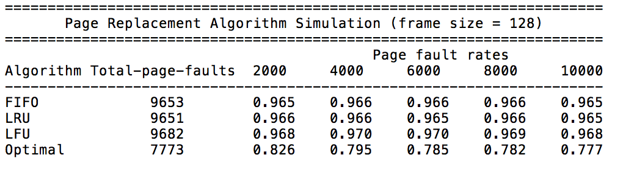

Output with command

**./memsim 256 pg-reference.txt output.txt**

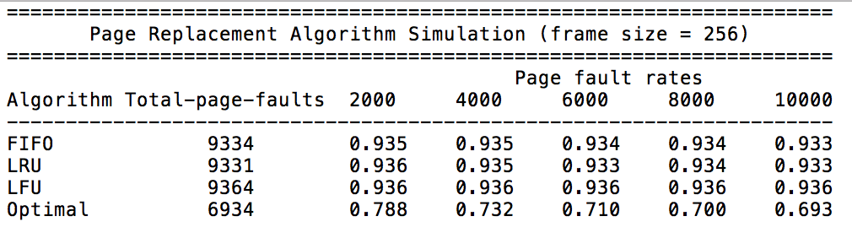

Output with command

**./memsim 512 pg-reference.txt output.txt**

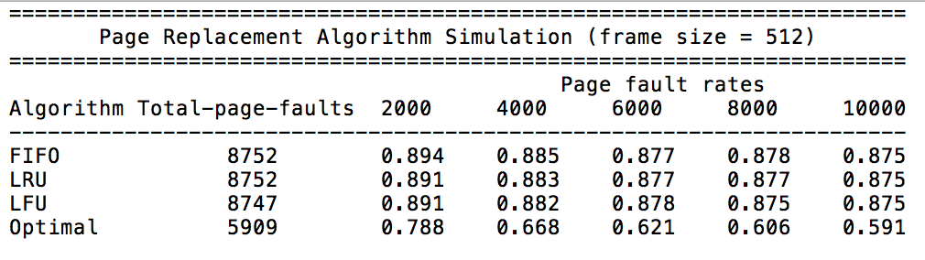

Output with command

**./memsim 1024 pg-reference.txt output.txt**

